Nylon

DuPont™ Minlon® reinforced nylon exhibits better dimensional stability and creep resistance than unreinforced nylon, and lower warpage than glass-reinforced nylon.

As a result, DuPont™ Minlon® reinforced nylon resin is a “workhorse” polymer commonly used in big industrial parts and demanding automobile applications. It can be processed readily in conventional thermoplastic molding equipment, providing versatility and potential efficiency. Minlon® has been widely tested and proven for a wide range of applications, making it easier to collaborate with DuPont experts to meet the specific performance, cost and production needs of new applications.

**USES AND APPLICATIONS**

* [**Plastics for Electrical & Electronics**](http://www.dupont.com/products-and-services/plastics-polymers-resins/thermoplastics/uses-and-applications/electrical-plastics.html)
* [**Hub Bushings For Copiers**](http://www.dupont.com/products-and-services/plastics-polymers-resins/thermoplastics/case-studies/hub-bushings-for-copiers.html)
* [**Lighter Engine Cover Components**](http://www.dupont.com/products-and-services/plastics-polymers-resins/thermoplastics/case-studies/lighter-engine-cover-components.html)

[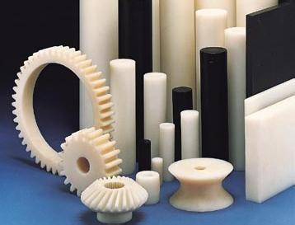](http://image.baidu.com/i?ct=503316480&z=&tn=baiduimagedetail&ipn=d&word=%E5%B0%BC%E9%BE%99%20%E4%BA%A7%E5%93%81&step_word=&ie=utf-8&in=1275&cl=2&lm=-1&st=-1&pn=45&rn=1&di=2096152300&ln=1999&fr=&&fmq=1392358117864_R&ic=0&s=&se=1&sme=0&tab=&width=&height=&face=0&is=&istype=2&ist=&jit=&objurl=http%3A%2F%2Fwww.500q.com%2Fuploadimg%2F20126111122025693.jpg)[](http://image.baidu.com/i?ct=503316480&z=&tn=baiduimagedetail&ipn=d&word=%E5%B0%BC%E9%BE%99%20%E4%BA%A7%E5%93%81&step_word=&ie=utf-8&in=25676&cl=2&lm=-1&st=-1&pn=65&rn=1&di=70845120280&ln=1999&fr=&&fmq=1392358117864_R&ic=0&s=&se=1&sme=0&tab=&width=&height=&face=0&is=&istype=2&ist=&jit=&objurl=http%3A%2F%2Fimages.qianyan.biz%2Fqy%2F8%2F9%2F2%2F20095191446959011004.jpg)